Deploy WAR on different ec2 using declarative pipeline

-Shweta Raut

Step 1 : create and ec2 instance

And configure tomcat server on it start tomcat

Step 2 : download ssh plugin on Jenkins dashboard

Configure it from manage Jenkins > system > ssh server

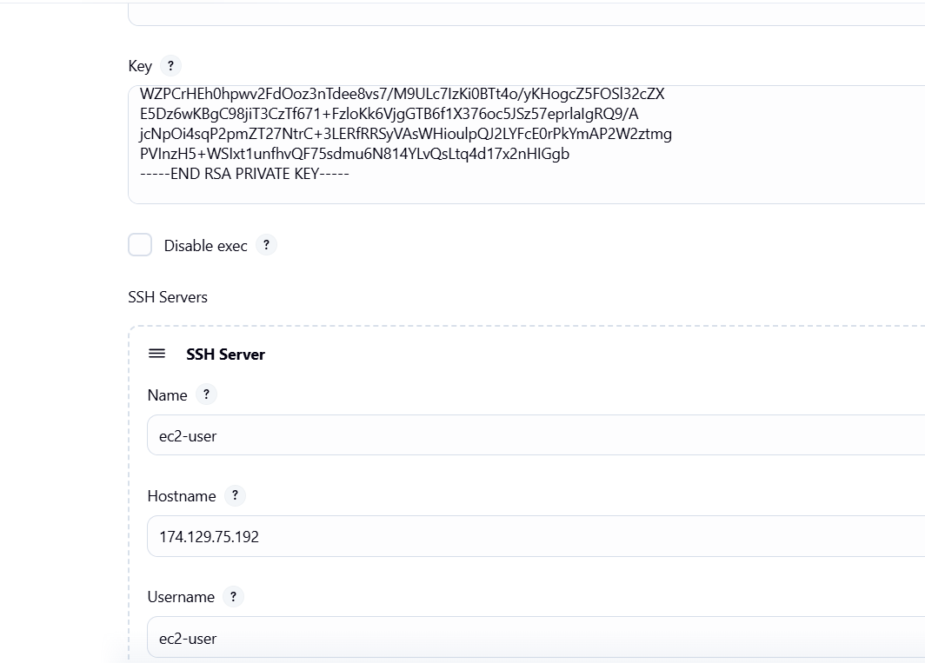

Create ssh pvt-key on master give permission of read only

Step: create declarative pipeline

pipeline{

    agent {

        label "built-in"

    }

     tools {

        maven 'maven'

        }

    stages{

        stage ("create war on master"){

            steps{

            sh "rm -rf \*"

            git branch: "master", url: "https://github.com/shwetaraut815/project.git"

            sh "mvn clean install"

            sh "scp -i /root/.ssh/pvt-key /root/.jenkins/workspace/war-to-ec2/target/LoginWebApp.war ec2-user@174.129.75.192:/mnt/server/apache-tomcat-10.1.46/webapps"

        }

        }

    }

}

Build it !

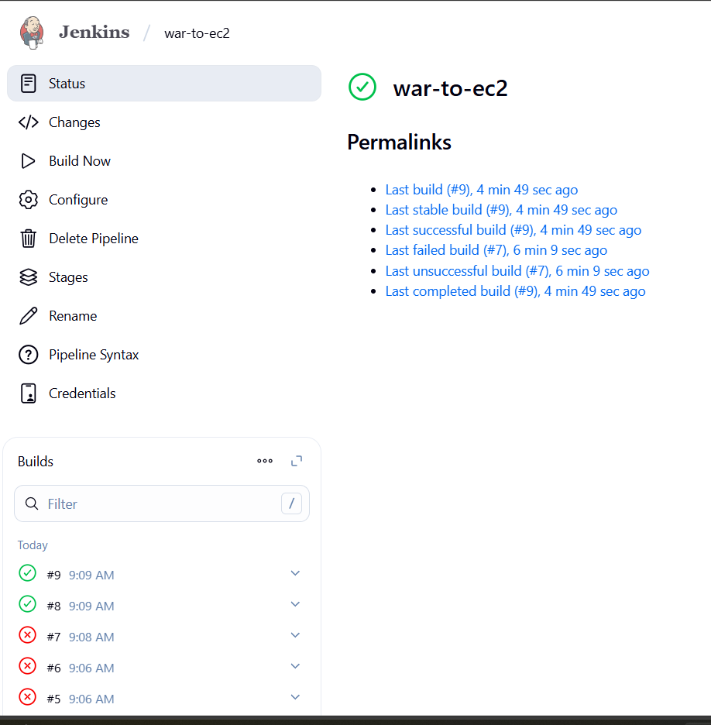

Access web application on browser from ec2-instance

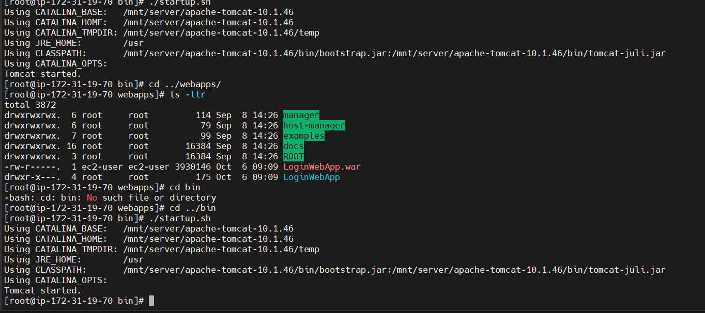

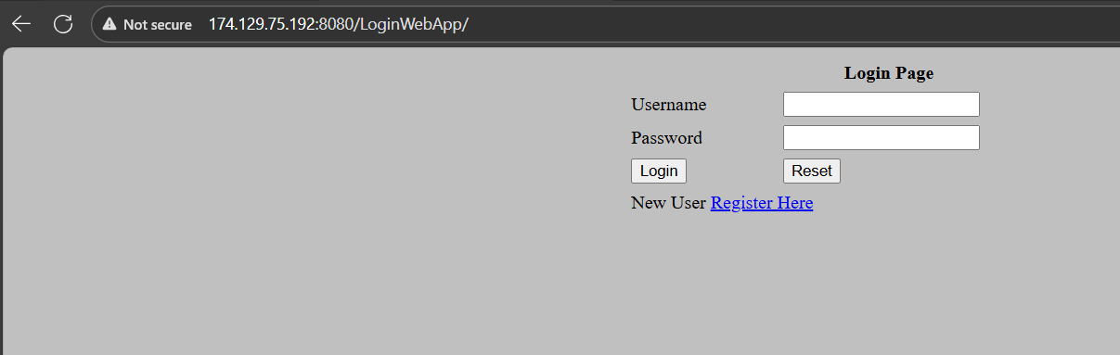

Done!!!!!